2.2
Evaluation:
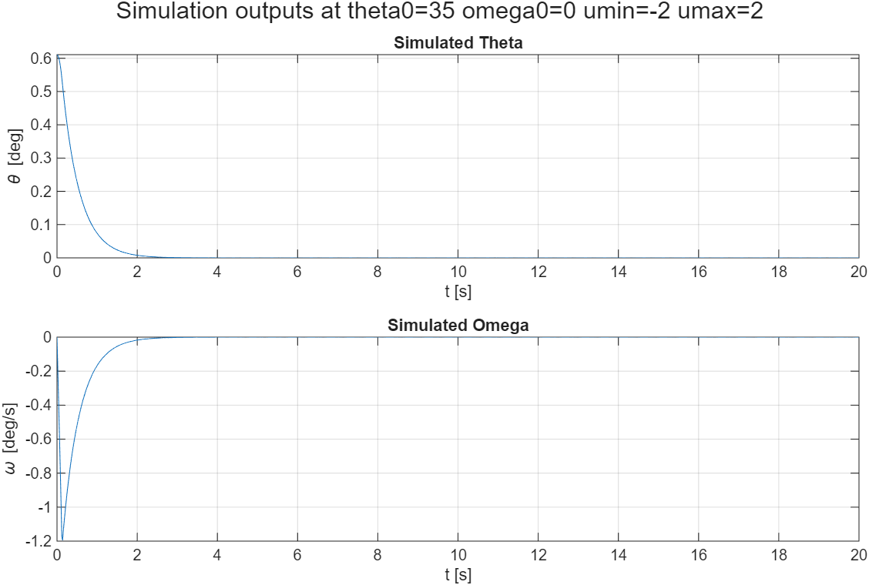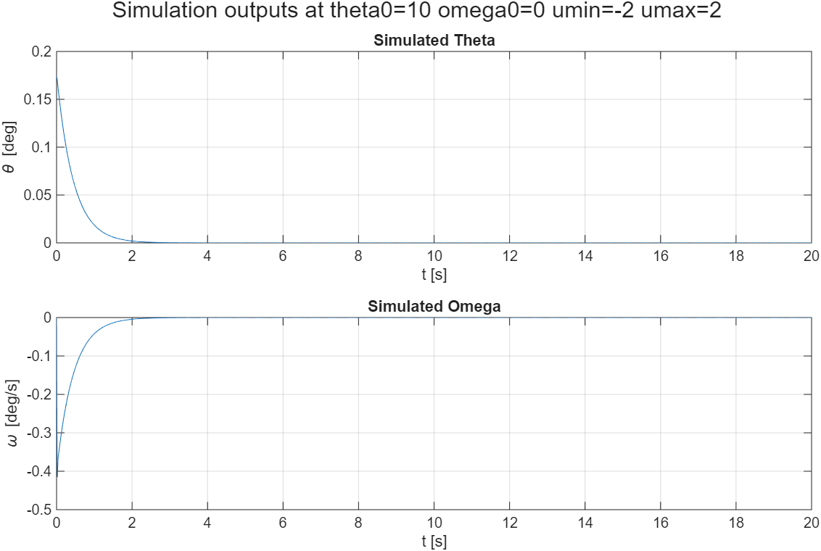

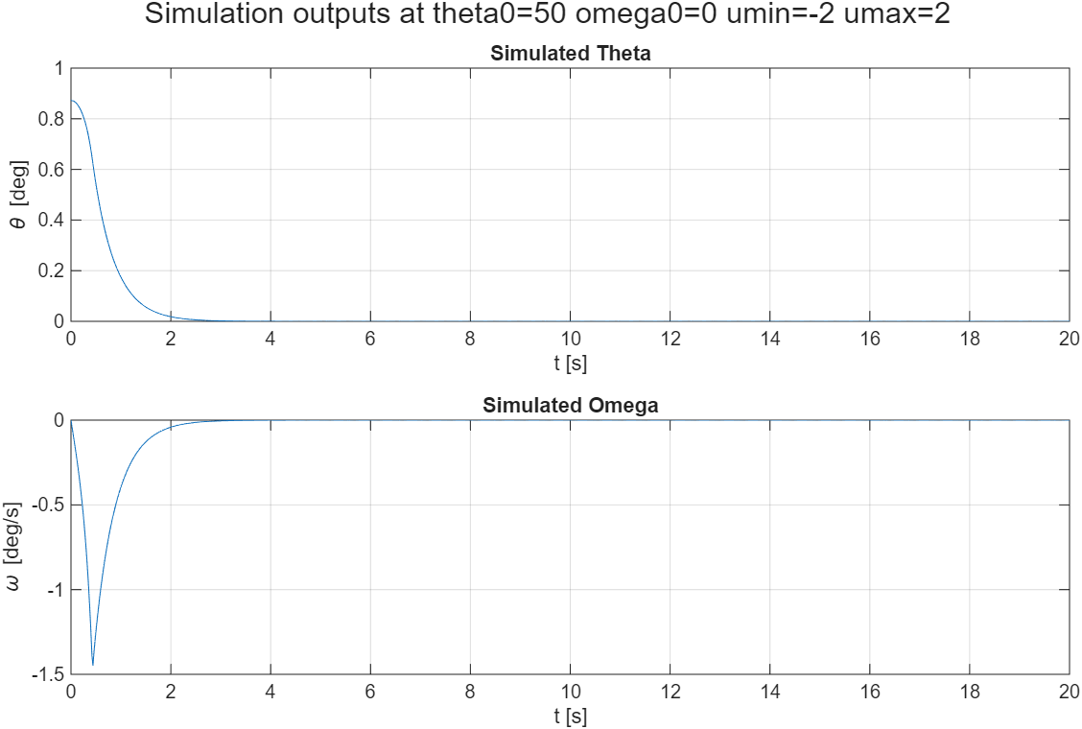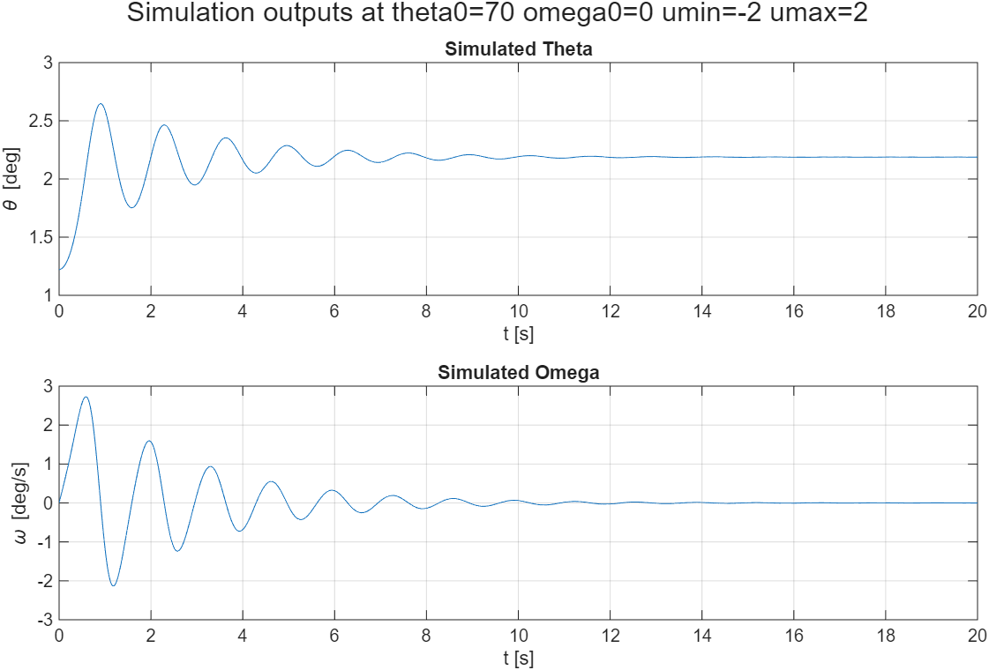
No, it is not always possible, for values sufficiently far away the system falls to its stable equilibrium stronger, hence an increase in max/min input would be required.

Choosing Q and R
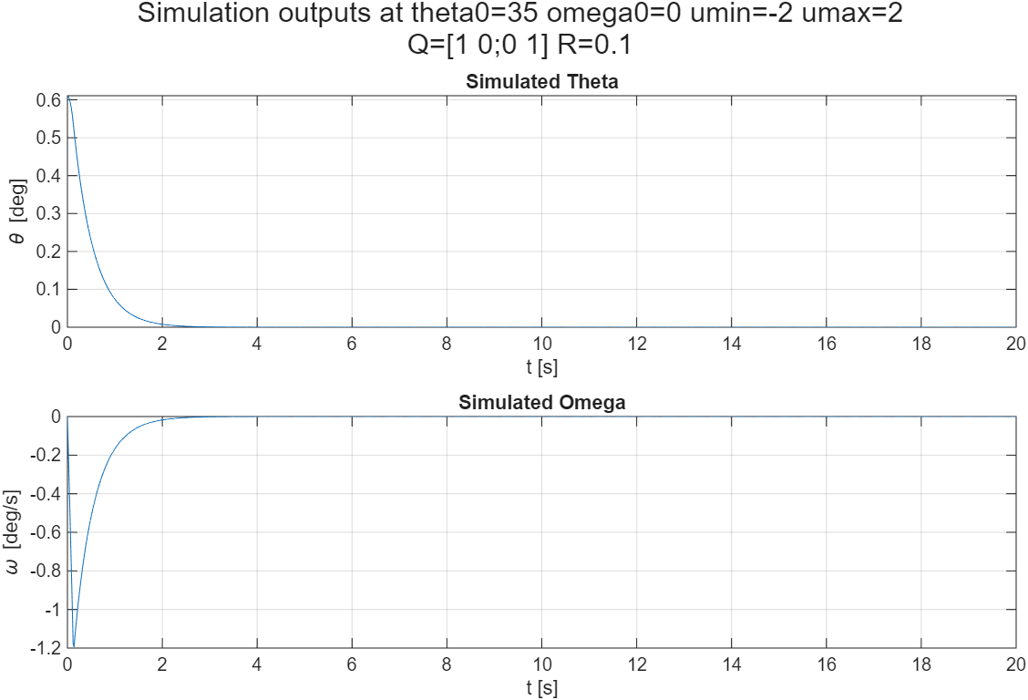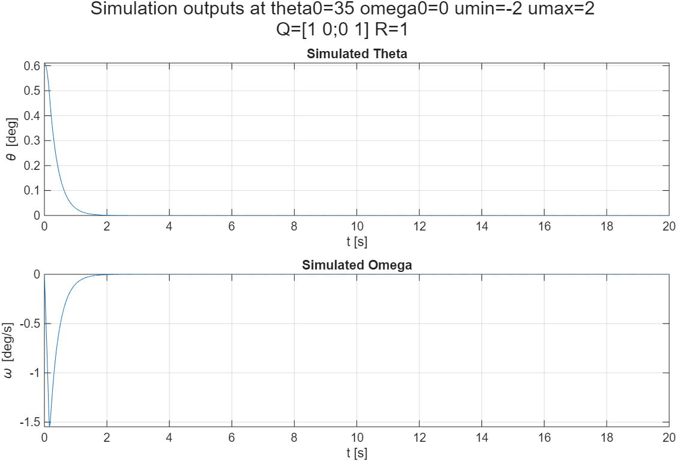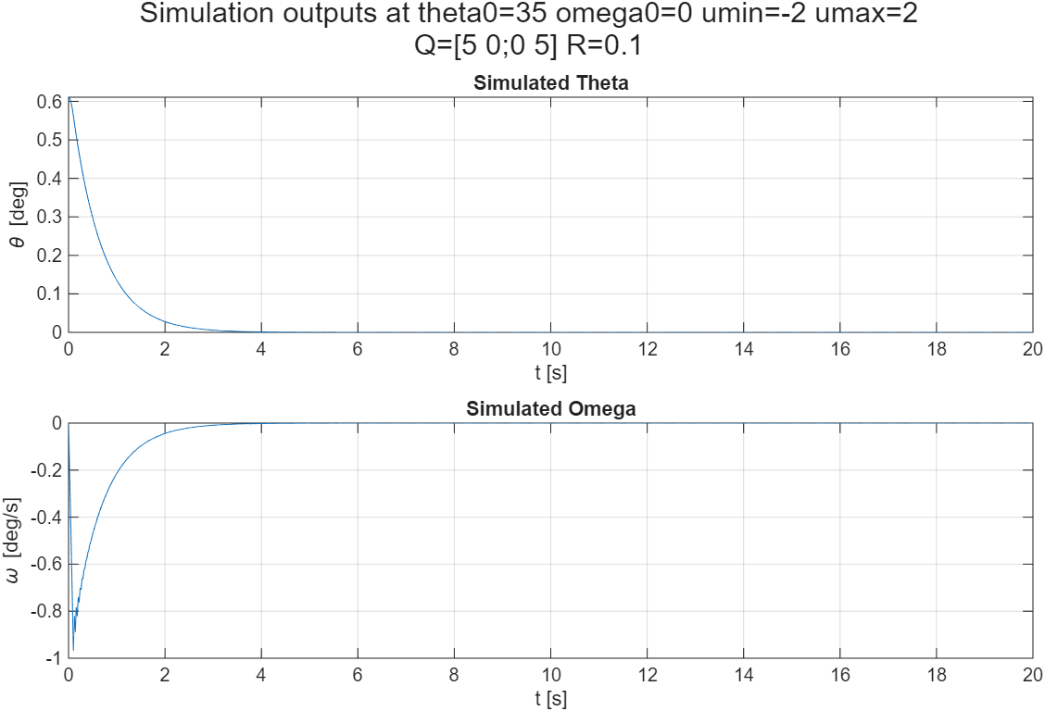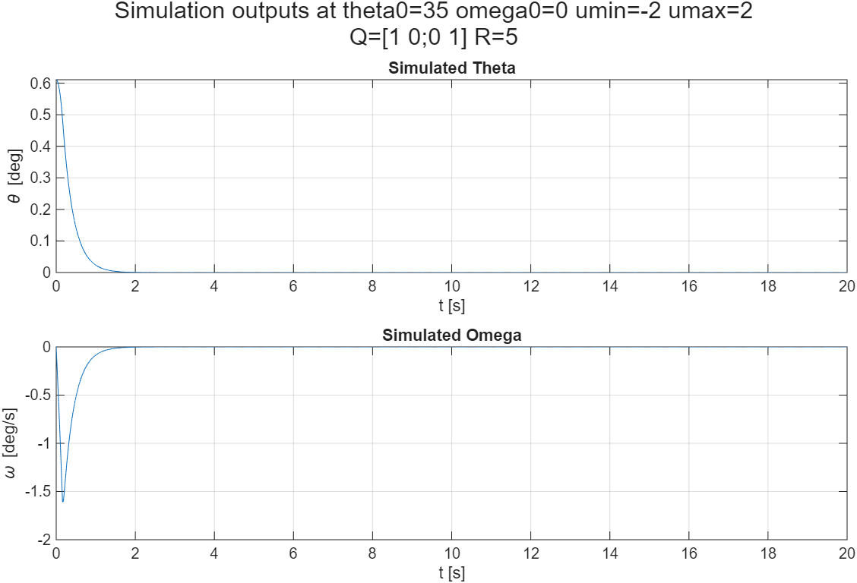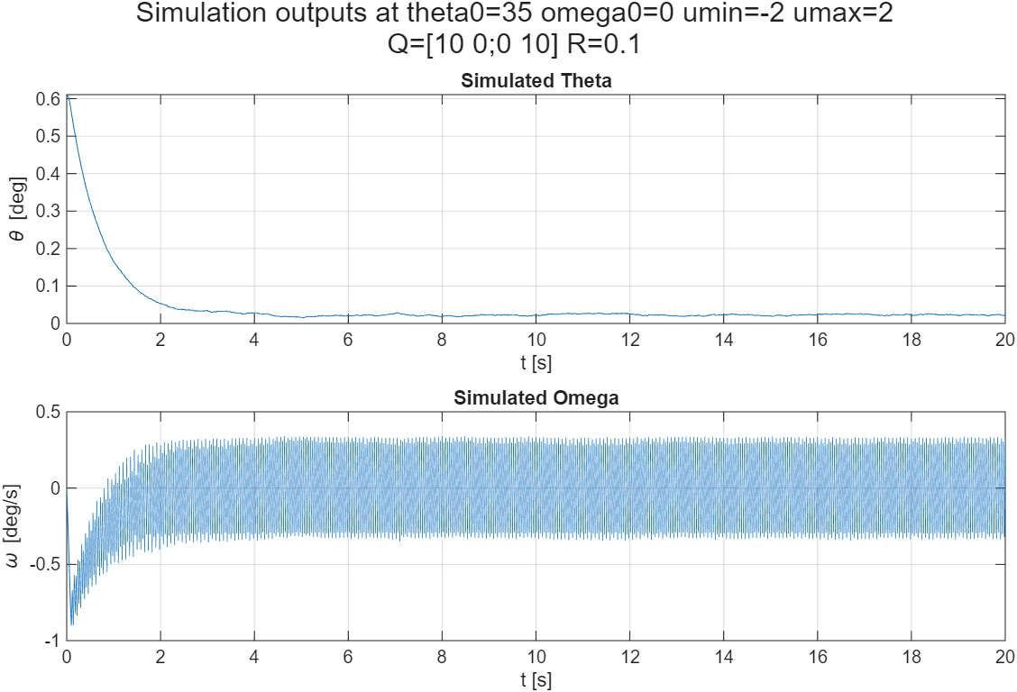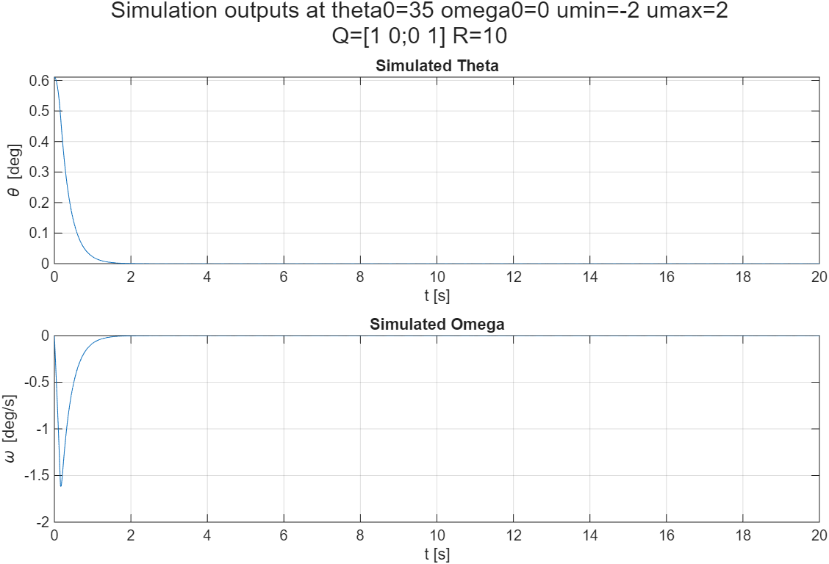
Larger Q leads to more aggressive control over the system (can be seen in lower |omega| in the system, which is more directly controlled), leading to more deliberate and faster convergence to the origin, but may lead to the instability of the controller for too large values. Larger R leads to more flattened action of the system, which may lead to its delayed action, hence in above examples the system prefers to wait for the better future opportunity reaching the origin (here 0.5 the pendulum’s rotation).
In the end, the trade-off requires the assessment of whether the system is required to stabilize quickly and whether its actions are supposed to be forceful.

Actuator limits
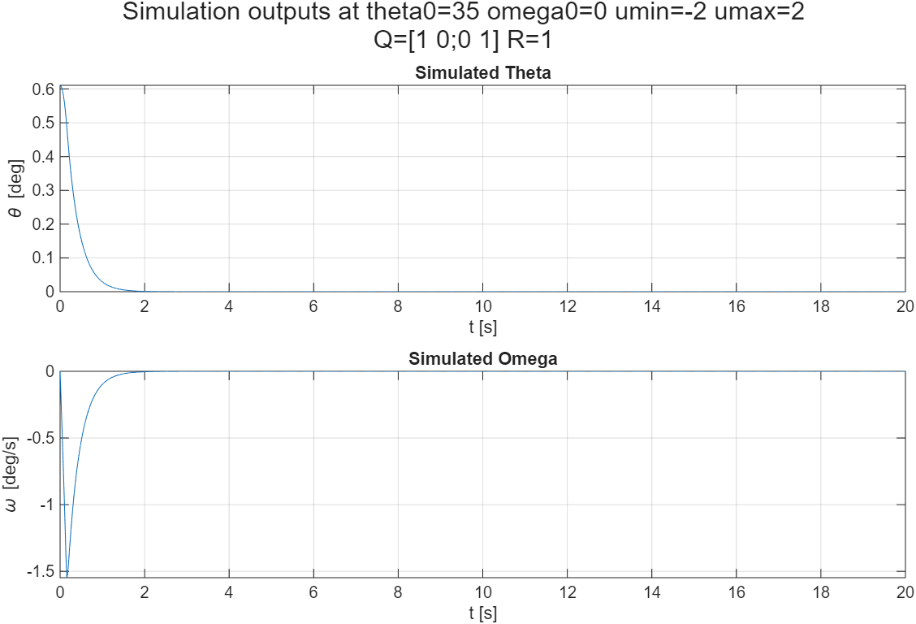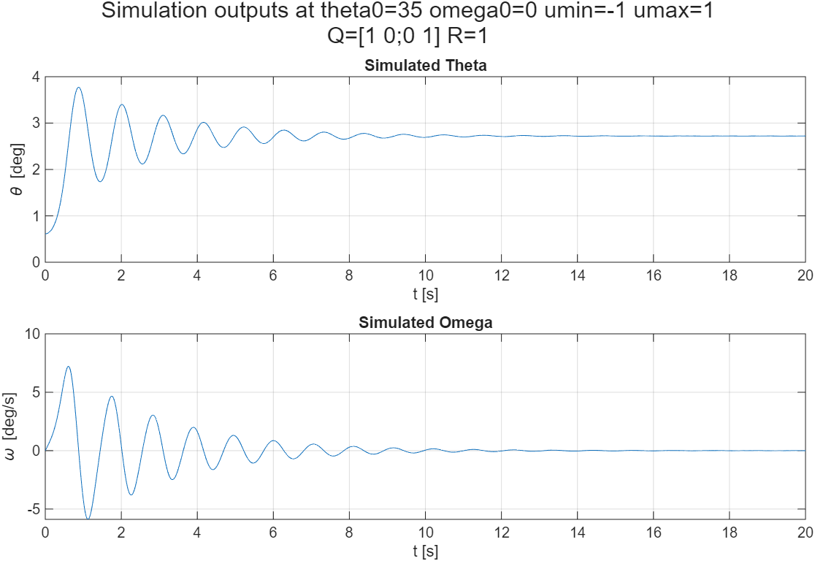
lower maximum torque makes more system space impossible to control to reach the desired state.

Disturbances
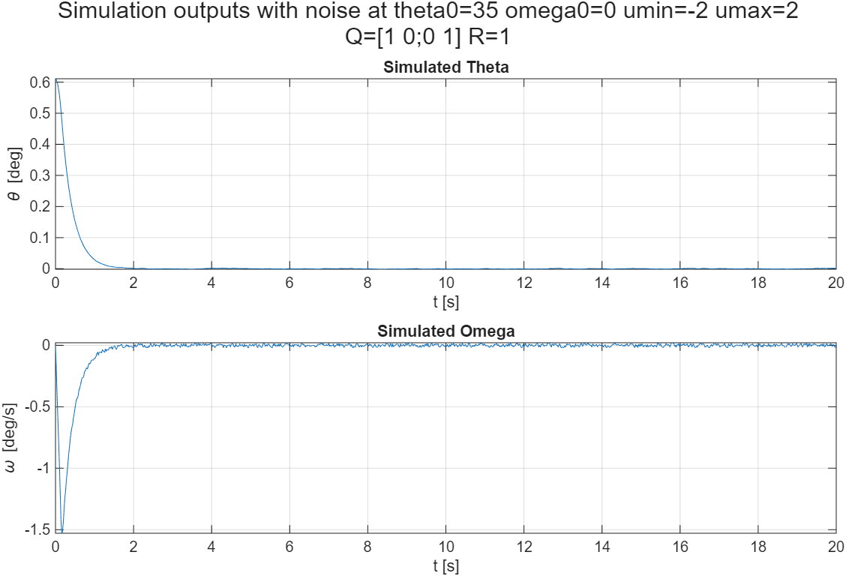
Noise added to the control leads to impossibility of the perfect stabilization of the system to the desired state. Especially one where small disturbance leads to the system converging to another equilibrium or diverging such as this.

Model uncertainties
The model’s predicted mass and length were modified independently. Title shows it’s known value which is faulty. Reference values are:
length = 0.5 m
mass = 1kg
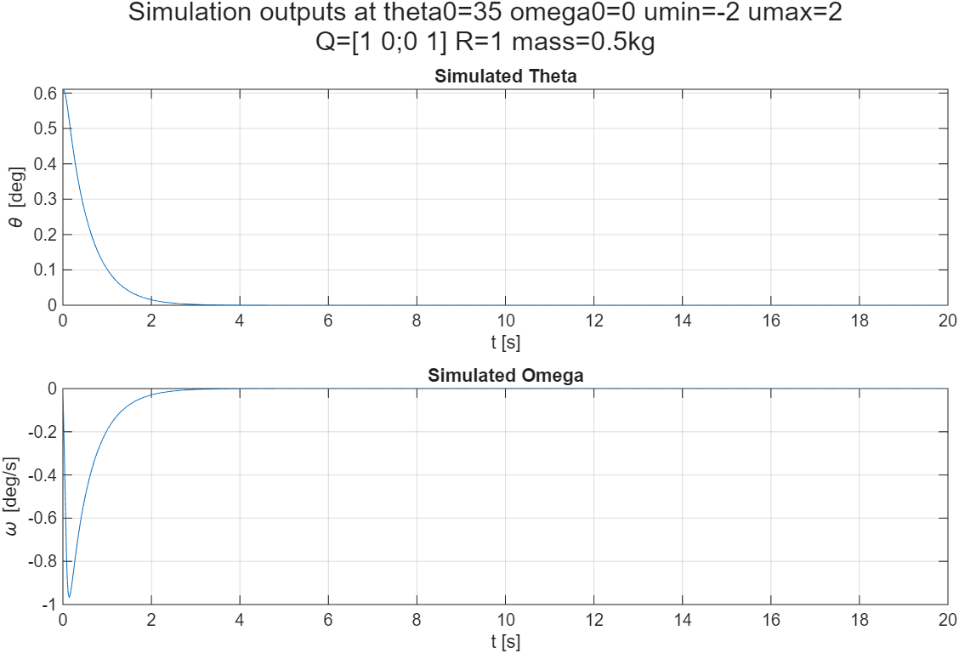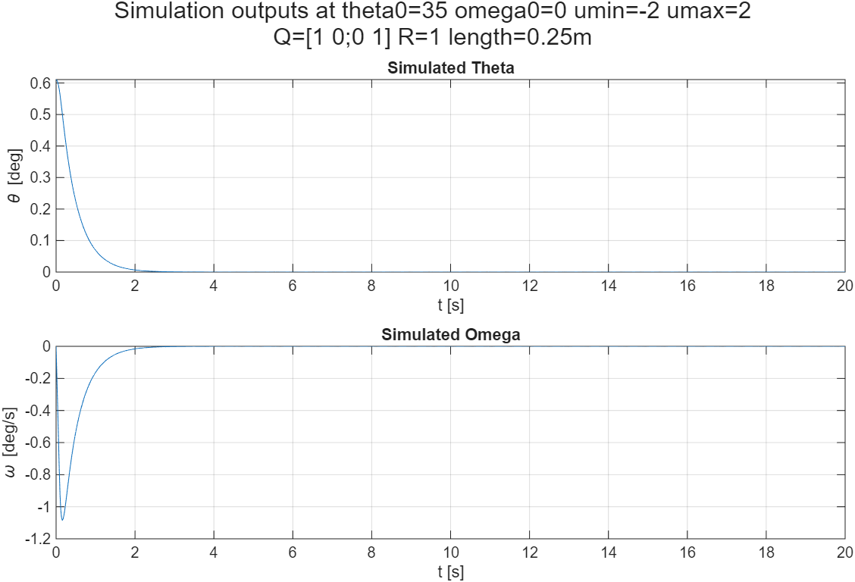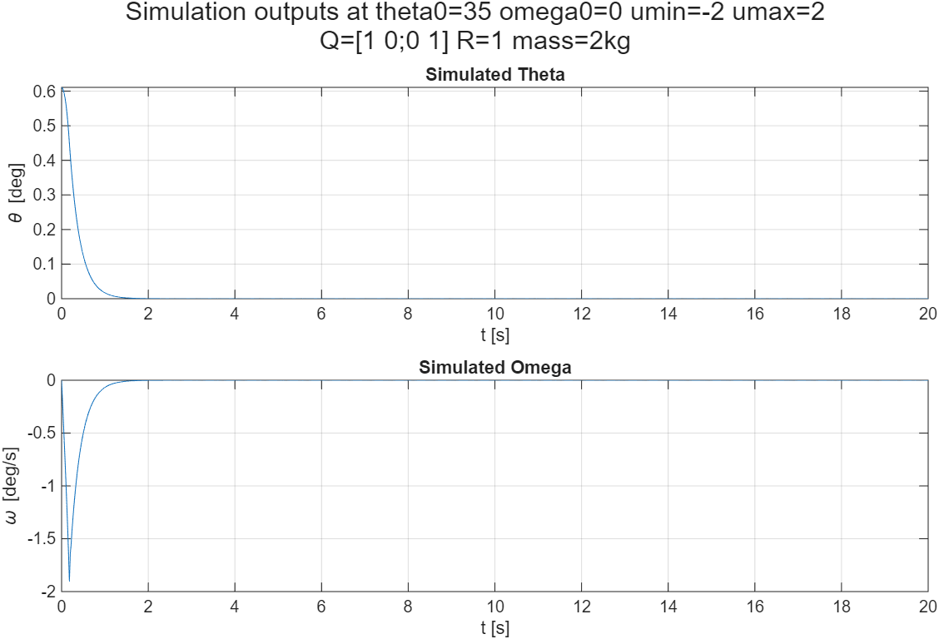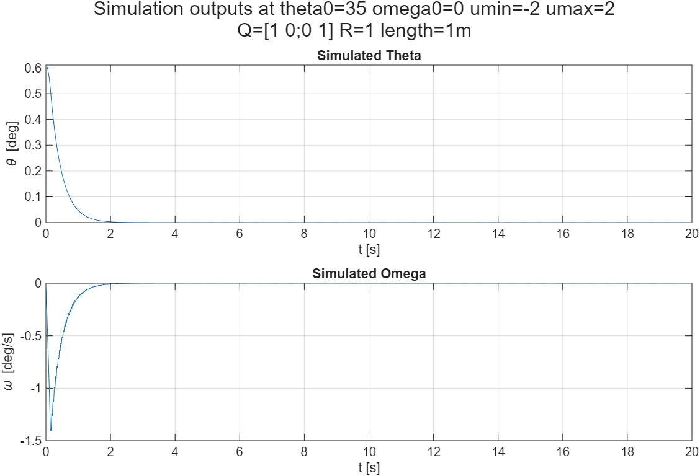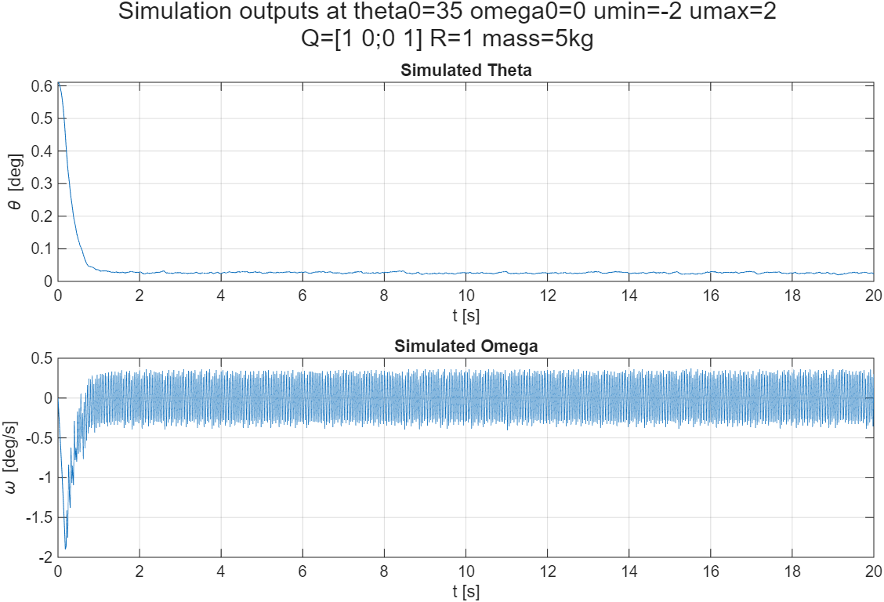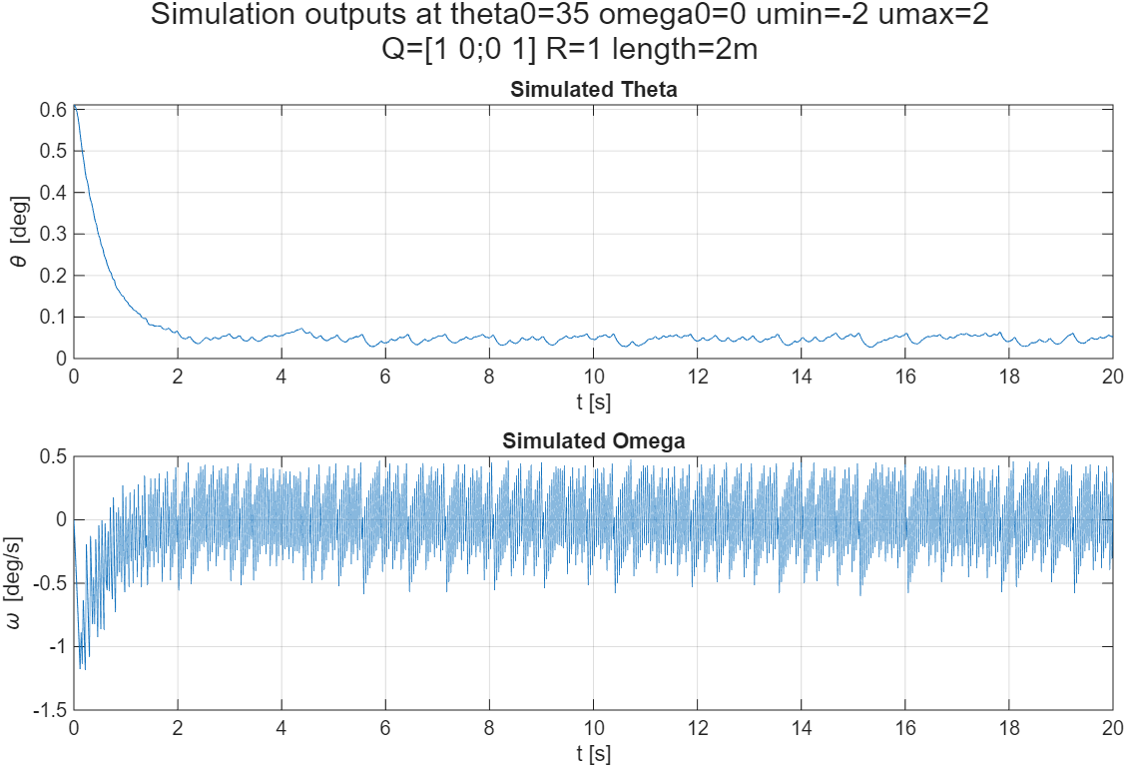
The model is resilient to faulty knowledge regarding the actual properties of the system, nevertheless if the error accumulates, the system fails to stabilize properly.

